Distribution System Analysis Subcommittee

IEEE 37 Node Test Feeder

IEEE 37 Node Test Feeder
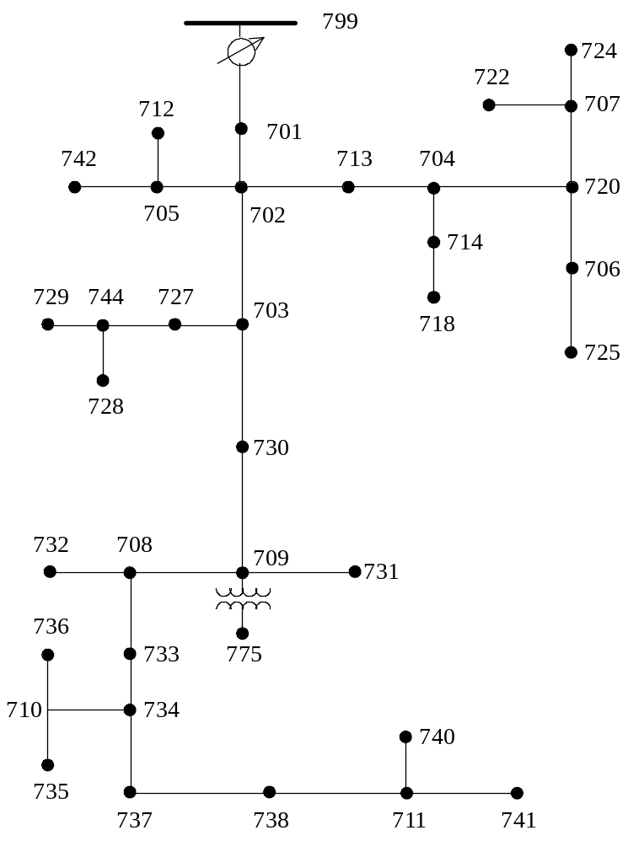

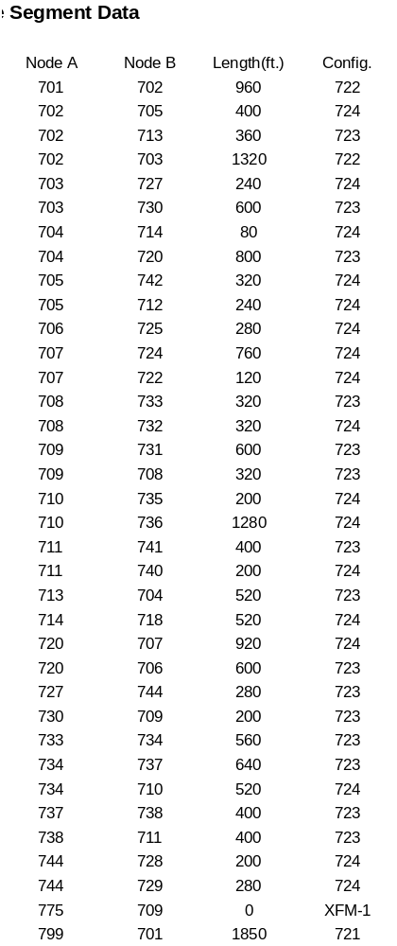
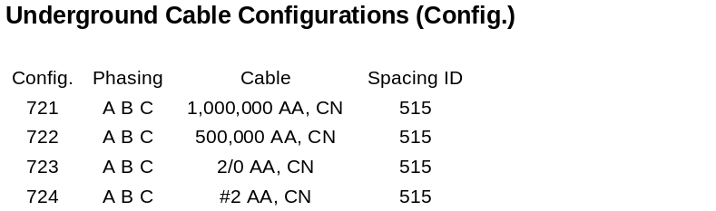
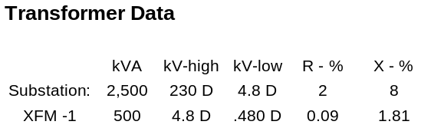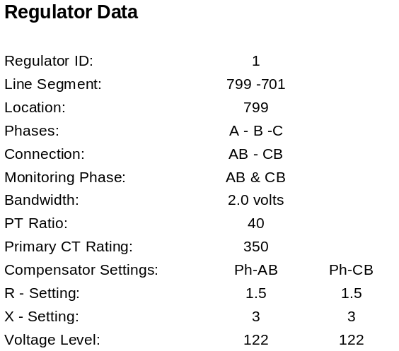
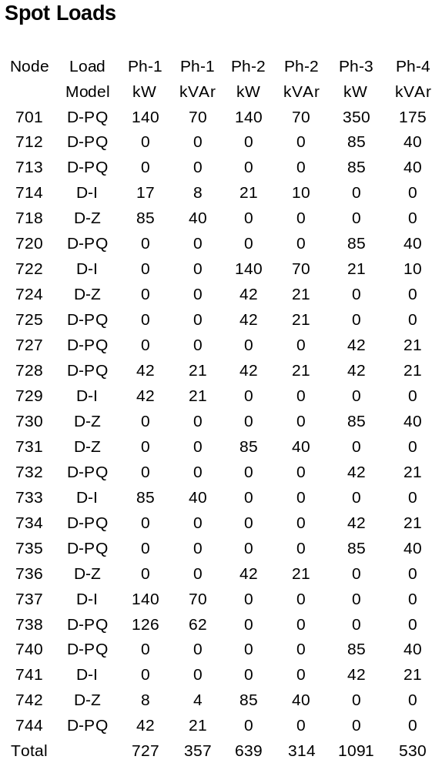

IEEE 37 NODE TEST FEEDER

Phase Impedance and Admittance Matrices

Configuration 721

Z (R +jX) in ohms per mile
0.2926 0.1973 0.0673 -0.0368 0.0337 -0.0417
0.2646 0.1900 0.0673 -0.0368
0.2926 0.1973
B in micro Siemens per mile
159.7919 0.0000 0.0000
159.7919 0.0000
159.7919

Configuration 722

Z (R +jX) in ohms per mile
0.4751 0.2973 0.1629 -0.0326 0.1234 -0.0607
0.4488 0.2678 0.1629 -0.0326
0.4751 0.2973
B in micro Siemens per mile
127.8306 0.0000 0.0000
127.8306 0.0000
127.8306

Configuration 723

Z (R +jX) in ohms per mile
1.2936 0.6713 0.4871 0.2111 0.4585 0.1521
1.3022 0.6326 0.4871 0.2111
1.2936 0.6713
B in micro Siemens per mile
74.8405 0.0000 0.0000
74.8405 0.0000
74.8405

Configuration 724

Z (R +jX) in ohms per mile
2.0952 0.7758 0.5204 0.2738 0.4926 0.2123
2.1068 0.7398 0.5204 0.2738
2.0952 0.7758
B in micro Siemens per mile
60.2483 0.0000 0.0000
60.2483 0.0000
60.2483
Power Flow Results

- R A D I A L F L O W S U M M A R Y - DATE: 6-24-2004 AT 16:23:14 HOURS ---
SUBSTATION: IEEE 37; FEEDER: IEEE 37
-------------------------------------------------------------------------------
SYSTEM PHASE PHASE PHASE TOTAL
INPUT -------(A)-------|-------(B)-------|-------(C)-------|------------------
kW : 895.496 | 683.879 | 942.452 | 2521.827
kVAr : 565.765 | 389.365 | 294.305 | 1249.435
kVA : 1059.246 | 786.954 | 987.335 | 2814.374
PF : .8454 | .8690 | .9545 | .8961

LOAD ------(A-B)------|------(B-C)------|------(C-A)------|------DELTA-------
kW : 732.331 | 638.824 | 1090.100 | 2461.255
kVAr : 359.538 | 313.874 | 529.558 | 1202.970
kVA : 815.829 | 711.768 | 1211.920 | 2739.510
PF : .8977 | .8975 | .8995 | .8984

LOSSES ------(A)-------|-------(B)-------|-------(C)-------|------------------
kW : 26.671 | 13.804 | 20.088 | 60.563
kVAr : 18.769 | 9.953 | 17.733 | 46.455
kVA : 32.613 | 17.018 | 26.796 | 76.328

CAPAC --(A-N)----(A-B)-|--(B-N)----(B-C)-|--(C-N)----(C-A)-|---WYE-----DELTA--
R-kVA: .0 .0| .0 .0| .0 .0| .0 .0
TOT : .000 | .000 | .000 | .000
| | |
A-kVA: .0 .0| .0 .0| .0 .0| .0 .0
TOT : .000 | .000 | .000 | .000

--- V O L T A G E P R O F I L E ---- DATE: 6-24-2004 AT 16:23:24 HOURS ----
SUBSTATION: IEEE 37; FEEDER: IEEE 37
-------------------------------------------------------------------------------
NODE | MAG ANGLE | MAG ANGLE | MAG ANGLE |mi.to SR
-------------------------------------------------------------------------------
______|_______ A-B ______ |_______ B-C _______ |_______ C-A _______ |
799 | 1.0000 at .00 | 1.0000 at -120.00 | 1.0000 at 120.00 | .000
RG7 | 1.0437 at .00 | 1.0250 at -120.00 | 1.0345 at 120.90 | .000
701 | 1.0317 at -.08 | 1.0144 at -120.39 | 1.0183 at 120.61 | .351
702 | 1.0248 at -.14 | 1.0088 at -120.58 | 1.0101 at 120.43 | .532
703 | 1.0178 at -.17 | 1.0051 at -120.70 | 1.0034 at 120.20 | .782
727 | 1.0167 at -.16 | 1.0044 at -120.69 | 1.0025 at 120.19 | .828
744 | 1.0160 at -.16 | 1.0041 at -120.68 | 1.0021 at 120.17 | .881
728 | 1.0156 at -.15 | 1.0037 at -120.68 | 1.0017 at 120.18 | .919
729 | 1.0157 at -.15 | 1.0040 at -120.67 | 1.0019 at 120.17 | .934
730 | 1.0127 at -.12 | 1.0021 at -120.73 | .9981 at 120.10 | .896
709 | 1.0111 at -.11 | 1.0012 at -120.73 | .9967 at 120.07 | .934
708 | 1.0087 at -.08 | 1.0002 at -120.73 | .9945 at 120.02 | .995
732 | 1.0086 at -.07 | 1.0001 at -120.74 | .9941 at 120.02 | 1.055
733 | 1.0063 at -.05 | .9993 at -120.73 | .9925 at 119.96 | 1.055
734 | 1.0029 at -.01 | .9978 at -120.74 | .9893 at 119.88 | 1.161
710 | 1.0024 at .01 | .9968 at -120.77 | .9878 at 119.91 | 1.260
735 | 1.0023 at .03 | .9966 at -120.78 | .9873 at 119.91 | 1.298
736 | 1.0019 at -.02 | .9951 at -120.75 | .9875 at 119.95 | 1.502
737 | .9996 at .02 | .9969 at -120.71 | .9872 at 119.79 | 1.282
738 | .9985 at .04 | .9965 at -120.71 | .9861 at 119.76 | 1.358
711 | .9982 at .06 | .9963 at -120.74 | .9852 at 119.76 | 1.434
740 | .9981 at .07 | .9961 at -120.75 | .9847 at 119.76 | 1.472
741 | .9981 at .07 | .9962 at -120.75 | .9849 at 119.76 | 1.510
731 | 1.0109 at -.13 | 1.0004 at -120.74 | .9964 at 120.10 | 1.048
XF7 | 1.0111 at -.11 | 1.0012 at -120.73 | .9967 at 120.07 | .934
775 | 1.0111 at -.11 | 1.0012 at -120.73 | .9967 at 120.07 | .934
705 | 1.0241 at -.13 | 1.0075 at -120.59 | 1.0088 at 120.46 | .608
712 | 1.0240 at -.11 | 1.0073 at -120.61 | 1.0082 at 120.46 | .654
742 | 1.0238 at -.15 | 1.0067 at -120.59 | 1.0086 at 120.48 | .669
713 | 1.0234 at -.15 | 1.0070 at -120.60 | 1.0083 at 120.44 | .601
704 | 1.0217 at -.17 | 1.0044 at -120.61 | 1.0065 at 120.46 | .699
714 | 1.0214 at -.17 | 1.0043 at -120.60 | 1.0064 at 120.46 | .714
718 | 1.0201 at -.16 | 1.0041 at -120.57 | 1.0060 at 120.42 | .813
720 | 1.0205 at -.21 | 1.0011 at -120.66 | 1.0041 at 120.53 | .851
706 | 1.0204 at -.22 | 1.0007 at -120.66 | 1.0039 at 120.54 | .964
725 | 1.0202 at -.23 | 1.0003 at -120.65 | 1.0039 at 120.55 | 1.017
707 | 1.0187 at -.30 | .9959 at -120.62 | 1.0025 at 120.67 | 1.025
722 | 1.0185 at -.30 | .9954 at -120.62 | 1.0023 at 120.68 | 1.048
724 | 1.0184 at -.32 | .9950 at -120.61 | 1.0023 at 120.69 | 1.169

----------- VOLTAGE REGULATOR DATA ---- DATE: 6-24-2004 AT 16:27:42 HOURS --
SUBSTATION: IEEE 37; FEEDER: IEEE 37
_______________________________________________________________________________
[NODE]--[VREG]-----[SEG]------[NODE] MODEL OPT BNDW
799 RG7 701 701 Phase AB & CB, Open Delta RX 2.00
........................................................................
PHASE LDCTR VOLT HOLD R-VOLT X-VOLT PT RATIO CT RATE TAP
1 122.000 1.500 3.000 40.00 350.00 7
3 122.000 1.500 3.000 40.00 350.00 4

- R A D I A L P O W E R F L O W --- DATE: 6-24-2004 AT 16:23:38 HOURS ---
SUBSTATION: IEEE 37; FEEDER: IEEE 37
-------------------------------------------------------------------------------
NODE VALUE PHASE A-B PHASE B-C PHASE C-A UNT O/L<
(LINE A) (LINE B) (LINE C) 60.%
---------------------*--------A-------*-------B-------*-------C-------*--------
NODE: 799 VOLTS: 1.000 .00 1.000 -120.00 1.000 120.00 MAG/ANG
kVll 4.800 NO LOAD OR CAPACITOR REPRESENTED AT SOURCE NODE

TO NODE RG7 <VRG>..: 382.22 -62.28 283.97 -179.65 356.27 72.66 AMP/DG <
<RG7 > LOSS= .000: ( .000) ( .000) ( .000) kW
---------------------*--------A-------*-------B-------*-------C-------*--------
NODE: RG7 VOLTS: 1.044 .00 1.025 -120.00 1.035 120.90 MAG/ANG
-LD: .00 .00 .00 .00 .00 .00 kW/kVR
kVll 4.800 CAP: .00 .00 .00 kVR

FROM NODE 799 <VRG>: 366.20 -62.28 274.03 -178.41 347.58 72.66 AMP/DG <
<RG7 > LOSS= .000: ( .000) ( .000) ( .000) kW
TO NODE 701 .......: 366.20 -62.28 274.03 -178.41 347.58 72.66 AMP/DG <
<701 > LOSS= 27.437: ( 11.802) ( 5.192) ( 10.443) kW
---------------------*--------A-------*-------B-------*-------C-------*--------
NODE: 701 VOLTS: 1.032 -.08 1.014 -120.39 1.018 120.61 MAG/ANG
D-LD: 140.00 70.00 140.00 70.00 350.00 175.00 kW/kVR
kVll 4.800 Y CAP: .00 .00 .00 kVR

FROM NODE RG7 .....: 366.29 -62.31 274.10 -178.44 347.63 72.63 AMP/DG <
<701 > LOSS= 27.437: ( 11.802) ( 5.192) ( 10.443) kW
TO NODE 702 .......: 267.63 -59.37 218.84 -178.93 248.48 70.62 AMP/DG
<702 > LOSS= 10.675: ( 4.633) ( 2.490) ( 3.552) kW
---------------------*--------A-------*-------B-------*-------C-------*--------
NODE: 702 VOLTS: 1.025 -.14 1.009 -120.58 1.010 120.43 MAG/ANG
-LD: .00 .00 .00 .00 .00 .00 kW/kVR
kVll 4.800 CAP: .00 .00 .00 kVR

FROM NODE 701 .....: 267.66 -59.39 218.87 -178.94 248.51 70.60 AMP/DG
<702 > LOSS= 10.675: ( 4.633) ( 2.490) ( 3.552) kW
TO NODE 703 .......: 189.70 -55.62 134.29 168.37 131.76 79.32 AMP/DG
<703 > LOSS= 5.803: ( 3.108) ( 1.290) ( 1.405) kW
TO NODE 705 .......: 20.46 -80.15 20.70 -150.32 33.68 64.53 AMP/DG
<705 > LOSS= .239: ( .053) ( .051) ( .135) kW
TO NODE 713 .......: 59.47 -64.41 72.39 -163.24 86.35 59.65 AMP/DG
<713 > LOSS= .908: ( .217) ( .292) ( .399) kW
---------------------*--------A-------*-------B-------*-------C-------*--------
NODE: 703 VOLTS: 1.018 -.17 1.005 -120.70 1.003 120.20 MAG/ANG
-LD: .00 .00 .00 .00 .00 .00 kW/kVR
kVll 4.800 CAP: .00 .00 .00 kVR

FROM NODE 702 .....: 189.73 -55.64 134.35 168.34 131.78 79.28 AMP/DG
<703 > LOSS= 5.803: ( 3.108) ( 1.290) ( 1.405) kW
TO NODE 727 .......: 42.39 -50.10 34.99 167.20 25.71 74.36 AMP/DG
<727 > LOSS= .266: ( .132) ( .088) ( .046) kW
TO NODE 730 .......: 147.60 -57.23 99.37 168.74 106.19 80.47 AMP/DG
<730 > LOSS= 4.021: ( 2.106) ( .915) ( 1.000) kW

- R A D I A L P O W E R F L O W --- DATE: 6-24-2004 AT 16:23:38 HOURS ---
SUBSTATION: IEEE 37; FEEDER: IEEE 37
-------------------------------------------------------------------------------
NODE VALUE PHASE A-B PHASE B-C PHASE C-A UNT O/L<
(LINE A) (LINE B) (LINE C) 60.%
---------------------*--------A-------*-------B-------*-------C-------*--------
NODE: 727 VOLTS: 1.017 -.16 1.004 -120.69 1.002 120.19 MAG/ANG
D-LD: .00 .00 .00 .00 42.00 21.00 kW/kVR
kVll 4.800 Y CAP: .00 .00 .00 kVR

FROM NODE 703 .....: 42.39 -50.11 35.00 167.19 25.71 74.34 AMP/DG
<727 > LOSS= .266: ( .132) ( .088) ( .046) kW
TO NODE 744 .......: 35.00 -40.61 35.00 167.19 16.81 63.30 AMP/DG
<744 > LOSS= .118: ( .054) ( .053) ( .011) kW
---------------------*--------A-------*-------B-------*-------C-------*--------
NODE: 744 VOLTS: 1.016 -.16 1.004 -120.68 1.002 120.17 MAG/ANG
D-LD: 42.00 21.00 .00 .00 .00 .00 kW/kVR
kVll 4.800 Y CAP: .00 .00 .00 kVR

FROM NODE 727 .....: 35.00 -40.63 35.01 167.17 16.82 63.26 AMP/DG
<744 > LOSS= .118: ( .054) ( .053) ( .011) kW
TO NODE 728 .......: 16.82 -56.76 16.82 -176.77 16.82 63.24 AMP/DG
<728 > LOSS= .051: ( .018) ( .017) ( .016) kW
TO NODE 729 .......: 9.78 -26.67 9.78 153.31 .01 .00 AMP/DG
<729 > LOSS= .016: ( .008) ( .008) ( .000) kW
---------------------*--------A-------*-------B-------*-------C-------*--------
NODE: 728 VOLTS: 1.016 -.15 1.004 -120.68 1.002 120.18 MAG/ANG
D-LD: 42.00 21.00 42.00 21.00 42.00 21.00 kW/kVR
kVll 4.800 Y CAP: .00 .00 .00 kVR

FROM NODE 744 .....: 16.83 -56.78 16.83 -176.79 16.83 63.22 AMP/DG
<728 > LOSS= .051: ( .018) ( .017) ( .016) kW
---------------------*--------A-------*-------B-------*-------C-------*--------
NODE: 729 VOLTS: 1.016 -.15 1.004 -120.67 1.002 120.17 MAG/ANG
D-LD: 42.66 21.33 .00 .00 .00 .00 kW/kVR
kVll 4.800 Y CAP: .00 .00 .00 kVR

FROM NODE 744 .....: 9.78 -26.72 9.78 153.28 .00 .00 AMP/DG
<729 > LOSS= .016: ( .008) ( .008) ( .000) kW
---------------------*--------A-------*-------B-------*-------C-------*--------
NODE: 730 VOLTS: 1.013 -.12 1.002 -120.73 .998 120.10 MAG/ANG
D-LD: .00 .00 .00 .00 84.69 39.85 kW/kVR
kVll 4.800 Y CAP: .00 .00 .00 kVR

FROM NODE 703 .....: 147.61 -57.24 99.38 168.73 106.19 80.46 AMP/DG
<730 > LOSS= 4.021: ( 2.106) ( .915) ( 1.000) kW
TO NODE 709 .......: 130.66 -53.24 99.38 168.73 87.41 77.27 AMP/DG
<709 > LOSS= 1.076: ( .549) ( .305) ( .222) kW

- R A D I A L P O W E R F L O W --- DATE: 6-24-2004 AT 16:23:38 HOURS ---
SUBSTATION: IEEE 37; FEEDER: IEEE 37
-------------------------------------------------------------------------------
NODE VALUE PHASE A-B PHASE B-C PHASE C-A UNT O/L<
(LINE A) (LINE B) (LINE C) 60.%
---------------------*--------A-------*-------B-------*-------C-------*--------
NODE: 709 VOLTS: 1.011 -.11 1.001 -120.73 .997 120.07 MAG/ANG
-LD: .00 .00 .00 .00 .00 .00 kW/kVR
kVll 4.800 CAP: .00 .00 .00 kVR

FROM NODE 730 .....: 130.67 -53.24 99.39 168.73 87.41 77.26 AMP/DG
<709 > LOSS= 1.076: ( .549) ( .305) ( .222) kW
TO NODE 708 .......: 130.67 -53.25 86.77 159.48 74.36 87.63 AMP/DG
<708 > LOSS= 1.503: ( .870) ( .372) ( .261) kW
TO NODE 731 .......: .02 .00 19.58 -145.87 19.56 34.10 AMP/DG
<731 > LOSS= .071: ( .000) ( .036) ( .035) kW
TO NODE XF7 .......: .00 .00 .00 .00 .00 .00 AMP/DG
<XF7 > LOSS= .000: ( .000) ( .000) ( .000) kW
---------------------*--------A-------*-------B-------*-------C-------*--------
NODE: 708 VOLTS: 1.009 -.08 1.000 -120.73 .994 120.02 MAG/ANG
-LD: .00 .00 .00 .00 .00 .00 kW/kVR
kVll 4.800 CAP: .00 .00 .00 kVR

FROM NODE 709 .....: 130.68 -53.25 86.78 159.48 74.36 87.62 AMP/DG
<708 > LOSS= 1.503: ( .870) ( .372) ( .261) kW
TO NODE 732 .......: 9.83 -86.51 .01 .00 9.84 93.51 AMP/DG
<732 > LOSS= .019: ( .009) ( .000) ( .009) kW
TO NODE 733 .......: 122.58 -50.73 86.79 159.47 64.57 86.72 AMP/DG
<733 > LOSS= 1.331: ( .764) ( .372) ( .195) kW
---------------------*--------A-------*-------B-------*-------C-------*--------
NODE: 732 VOLTS: 1.009 -.07 1.000 -120.74 .994 120.02 MAG/ANG
D-LD: .00 .00 .00 .00 42.00 21.00 kW/kVR
kVll 4.800 Y CAP: .00 .00 .00 kVR

FROM NODE 708 .....: 9.84 -86.55 .00 .00 9.84 93.45 AMP/DG
<732 > LOSS= .019: ( .009) ( .000) ( .009) kW
---------------------*--------A-------*-------B-------*-------C-------*--------
NODE: 733 VOLTS: 1.006 -.05 .999 -120.73 .993 119.96 MAG/ANG
D-LD: 85.53 40.25 .00 .00 .00 .00 kW/kVR
kVll 4.800 Y CAP: .00 .00 .00 kVR

FROM NODE 708 .....: 122.58 -50.74 86.80 159.47 64.57 86.71 AMP/DG
<733 > LOSS= 1.331: ( .764) ( .372) ( .195) kW
TO NODE 734 .......: 105.25 -55.33 67.31 160.84 64.57 86.71 AMP/DG
<734 > LOSS= 1.729: ( .990) ( .392) ( .347) kW

- R A D I A L P O W E R F L O W --- DATE: 6-24-2004 AT 16:23:38 HOURS ---
SUBSTATION: IEEE 37; FEEDER: IEEE 37
-------------------------------------------------------------------------------
NODE VALUE PHASE A-B PHASE B-C PHASE C-A UNT O/L<
(LINE A) (LINE B) (LINE C) 60.%
---------------------*--------A-------*-------B-------*-------C-------*--------
NODE: 734 VOLTS: 1.003 -.01 .998 -120.74 .989 119.88 MAG/ANG
D-LD: .00 .00 .00 .00 42.00 21.00 kW/kVR
kVll 4.800 Y CAP: .00 .00 .00 kVR

FROM NODE 733 .....: 105.26 -55.34 67.33 160.83 64.58 86.69 AMP/DG
<734 > LOSS= 1.729: ( .990) ( .392) ( .347) kW
TO NODE 710 .......: 19.77 -85.19 9.74 -146.94 25.85 75.43 AMP/DG
<710 > LOSS= .182: ( .063) ( .015) ( .104) kW
TO NODE 737 .......: 81.06 -44.69 61.84 153.68 29.66 94.26 AMP/DG
<737 > LOSS= 1.119: ( .660) ( .378) ( .081) kW
---------------------*--------A-------*-------B-------*-------C-------*--------
NODE: 710 VOLTS: 1.002 .01 .997 -120.77 .988 119.91 MAG/ANG
-LD: .00 .00 .00 .00 .00 .00 kW/kVR
kVll 4.800 CAP: .00 .00 .00 kVR

FROM NODE 734 .....: 19.78 -85.21 9.74 -147.04 25.85 75.39 AMP/DG
<710 > LOSS= .182: ( .063) ( .015) ( .104) kW
TO NODE 735 .......: 19.82 -85.28 .01 .00 19.82 94.73 AMP/DG
<735 > LOSS= .048: ( .024) ( .000) ( .024) kW
TO NODE 736 .......: .04 .00 9.74 -147.08 9.70 32.81 AMP/DG
<736 > LOSS= .073: ( .000) ( .037) ( .036) kW
---------------------*--------A-------*-------B-------*-------C-------*--------
NODE: 735 VOLTS: 1.002 .03 .997 -120.78 .987 119.91 MAG/ANG
D-LD: .00 .00 .00 .00 85.00 40.00 kW/kVR
kVll 4.800 Y CAP: .00 .00 .00 kVR

FROM NODE 710 .....: 19.82 -85.29 .00 .00 19.82 94.71 AMP/DG
<735 > LOSS= .048: ( .024) ( .000) ( .024) kW
---------------------*--------A-------*-------B-------*-------C-------*--------
NODE: 736 VOLTS: 1.002 -.02 .995 -120.75 .987 119.95 MAG/ANG
D-LD: .00 .00 41.59 20.80 .00 .00 kW/kVR
kVll 4.800 Y CAP: .00 .00 .00 kVR

FROM NODE 710 .....: .00 .00 9.74 -147.31 9.74 32.69 AMP/DG
<736 > LOSS= .073: ( .000) ( .037) ( .036) kW
---------------------*--------A-------*-------B-------*-------C-------*--------
NODE: 737 VOLTS: 1.000 .02 .997 -120.71 .987 119.79 MAG/ANG
D-LD: 139.94 69.97 .00 .00 .00 .00 kW/kVR
kVll 4.800 Y CAP: .00 .00 .00 kVR

FROM NODE 734 .....: 81.07 -44.70 61.87 153.66 29.66 94.21 AMP/DG
<737 > LOSS= 1.119: ( .660) ( .378) ( .081) kW
TO NODE 738 .......: 51.10 -56.17 29.26 153.90 29.66 94.21 AMP/DG
<738 > LOSS= .272: ( .166) ( .053) ( .053) kW

- R A D I A L P O W E R F L O W --- DATE: 6-24-2004 AT 16:23:38 HOURS ---
SUBSTATION: IEEE 37; FEEDER: IEEE 37
-------------------------------------------------------------------------------
NODE VALUE PHASE A-B PHASE B-C PHASE C-A UNT O/L<
(LINE A) (LINE B) (LINE C) 60.%
---------------------*--------A-------*-------B-------*-------C-------*--------
NODE: 738 VOLTS: .998 .04 .996 -120.71 .986 119.76 MAG/ANG
D-LD: 126.00 62.00 .00 .00 .00 .00 kW/kVR
kVll 4.800 Y CAP: .00 .00 .00 kVR

FROM NODE 737 .....: 51.11 -56.19 29.27 153.88 29.66 94.18 AMP/DG
<738 > LOSS= .272: ( .166) ( .053) ( .053) kW
TO NODE 711 .......: 29.63 -85.85 .04 .00 29.66 94.18 AMP/DG
<711 > LOSS= .111: ( .056) ( .000) ( .056) kW
---------------------*--------A-------*-------B-------*-------C-------*--------
NODE: 711 VOLTS: .998 .06 .996 -120.74 .985 119.76 MAG/ANG
-LD: .00 .00 .00 .00 .00 .00 kW/kVR
kVll 4.800 CAP: .00 .00 .00 kVR

FROM NODE 738 .....: 29.64 -85.87 .02 .00 29.66 94.15 AMP/DG
<711 > LOSS= .111: ( .056) ( .000) ( .056) kW
TO NODE 740 .......: 19.87 -85.43 .01 .00 19.88 94.58 AMP/DG
<740 > LOSS= .048: ( .024) ( .000) ( .024) kW
TO NODE 741 .......: 9.77 -86.76 .02 .00 9.78 93.28 AMP/DG
<741 > LOSS= .012: ( .006) ( .000) ( .006) kW
---------------------*--------A-------*-------B-------*-------C-------*--------
NODE: 740 VOLTS: .998 .07 .996 -120.75 .985 119.76 MAG/ANG
D-LD: .00 .00 .00 .00 85.00 40.00 kW/kVR
kVll 4.800 Y CAP: .00 .00 .00 kVR

FROM NODE 711 .....: 19.88 -85.44 .00 .00 19.88 94.56 AMP/DG
<740 > LOSS= .048: ( .024) ( .000) ( .024) kW
---------------------*--------A-------*-------B-------*-------C-------*--------
NODE: 741 VOLTS: .998 .07 .996 -120.75 .985 119.76 MAG/ANG
D-LD: .00 .00 .00 .00 41.37 20.68 kW/kVR
kVll 4.800 Y CAP: .00 .00 .00 kVR

FROM NODE 711 .....: 9.78 -86.81 .00 .00 9.78 93.19 AMP/DG
<741 > LOSS= .012: ( .006) ( .000) ( .006) kW
---------------------*--------A-------*-------B-------*-------C-------*--------
NODE: 731 VOLTS: 1.011 -.13 1.000 -120.74 .996 120.10 MAG/ANG
D-LD: .00 .00 85.06 40.03 .00 .00 kW/kVR
kVll 4.800 Y CAP: .00 .00 .00 kVR

FROM NODE 709 .....: .00 .00 19.58 -145.94 19.58 34.06 AMP/DG
<731 > LOSS= .071: ( .000) ( .036) ( .035) kW
---------------------*--------A-------*-------B-------*-------C-------*--------
NODE: XF7 VOLTS: 1.011 -.11 1.001 -120.73 .997 120.07 MAG/ANG
-LD: .00 .00 .00 .00 .00 .00 kW/kVR
kVll .480 CAP: .00 .00 .00 kVR

FROM NODE 709 .....: .00 .00 .00 .00 .00 .00 AMP/DG
<XF7 > LOSS= .000: ( .000) ( .000) ( .000) kW
TO NODE 775 .......: .00 .00 .00 .00 .00 .00 AMP/DG
<775 > LOSS= .000: ( .000) ( .000) ( .000) kW

- R A D I A L P O W E R F L O W --- DATE: 6-24-2004 AT 16:23:38 HOURS ---
SUBSTATION: IEEE 37; FEEDER: IEEE 37
-------------------------------------------------------------------------------
NODE VALUE PHASE A-B PHASE B-C PHASE C-A UNT O/L<
(LINE A) (LINE B) (LINE C) 60.%
---------------------*--------A-------*-------B-------*-------C-------*--------
NODE: 775 VOLTS: 1.011 -.11 1.001 -120.73 .997 120.07 MAG/ANG
-LD: .00 .00 .00 .00 .00 .00 kW/kVR
kVll .480 CAP: .00 .00 .00 kVR

FROM NODE XF7 .....: .00 .00 .00 .00 .00 .00 AMP/DG
<775 > LOSS= .000: ( .000) ( .000) ( .000) kW
---------------------*--------A-------*-------B-------*-------C-------*--------
NODE: 705 VOLTS: 1.024 -.13 1.008 -120.59 1.009 120.46 MAG/ANG
-LD: .00 .00 .00 .00 .00 .00 kW/kVR
kVll 4.800 CAP: .00 .00 .00 kVR

FROM NODE 702 .....: 20.47 -80.18 20.70 -150.36 33.69 64.51 AMP/DG
<705 > LOSS= .239: ( .053) ( .051) ( .135) kW
TO NODE 712 .......: 19.41 -84.73 .01 .00 19.41 95.28 AMP/DG
<712 > LOSS= .055: ( .027) ( .000) ( .027) kW
TO NODE 742 .......: 1.91 -26.40 20.70 -150.38 19.69 34.23 AMP/DG
<742 > LOSS= .079: ( .000) ( .041) ( .037) kW
---------------------*--------A-------*-------B-------*-------C-------*--------
NODE: 712 VOLTS: 1.024 -.11 1.007 -120.61 1.008 120.46 MAG/ANG
D-LD: .00 .00 .00 .00 85.00 40.00 kW/kVR
kVll 4.800 Y CAP: .00 .00 .00 kVR

FROM NODE 705 .....: 19.41 -84.74 .00 .00 19.41 95.26 AMP/DG
<712 > LOSS= .055: ( .027) ( .000) ( .027) kW
---------------------*--------A-------*-------B-------*-------C-------*--------
NODE: 742 VOLTS: 1.024 -.15 1.007 -120.59 1.009 120.48 MAG/ANG
D-LD: 8.39 4.19 86.14 40.54 .00 .00 kW/kVR
kVll 4.800 Y CAP: .00 .00 .00 kVR

FROM NODE 705 .....: 1.91 -26.71 20.70 -150.41 19.70 34.21 AMP/DG
<742 > LOSS= .079: ( .000) ( .041) ( .037) kW
---------------------*--------A-------*-------B-------*-------C-------*--------
NODE: 713 VOLTS: 1.023 -.15 1.007 -120.60 1.008 120.44 MAG/ANG
D-LD: .00 .00 .00 .00 85.00 40.00 kW/kVR
kVll 4.800 Y CAP: .00 .00 .00 kVR

FROM NODE 702 .....: 59.48 -64.42 72.40 -163.25 86.35 59.64 AMP/DG
<713 > LOSS= .908: ( .217) ( .292) ( .399) kW
TO NODE 704 .......: 41.83 -55.14 72.40 -163.25 71.47 50.54 AMP/DG
<704 > LOSS= .970: ( .158) ( .421) ( .391) kW

- R A D I A L P O W E R F L O W --- DATE: 6-24-2004 AT 16:23:38 HOURS ---
SUBSTATION: IEEE 37; FEEDER: IEEE 37
-------------------------------------------------------------------------------
NODE VALUE PHASE A-B PHASE B-C PHASE C-A UNT O/L<
(LINE A) (LINE B) (LINE C) 60.%
---------------------*--------A-------*-------B-------*-------C-------*--------
NODE: 704 VOLTS: 1.022 -.17 1.004 -120.61 1.006 120.46 MAG/ANG
-LD: .00 .00 .00 .00 .00 .00 kW/kVR
kVll 4.800 CAP: .00 .00 .00 kVR

FROM NODE 713 .....: 41.84 -55.17 72.40 -163.27 71.48 50.53 AMP/DG
<704 > LOSS= .970: ( .158) ( .421) ( .391) kW
TO NODE 714 .......: 23.88 -25.32 26.67 163.65 4.83 34.06 AMP/DG
<714 > LOSS= .031: ( .014) ( .017) ( .000) kW
TO NODE 720 .......: 24.24 -84.53 52.13 -147.06 66.86 51.70 AMP/DG
<720 > LOSS= .964: ( .087) ( .336) ( .542) kW
---------------------*--------A-------*-------B-------*-------C-------*--------
NODE: 714 VOLTS: 1.021 -.17 1.004 -120.60 1.006 120.46 MAG/ANG
D-LD: 17.36 8.17 21.09 10.04 .00 .00 kW/kVR
kVll 4.800 Y CAP: .00 .00 .00 kVR

FROM NODE 704 .....: 23.88 -25.33 26.67 163.64 4.83 34.04 AMP/DG
<714 > LOSS= .031: ( .014) ( .017) ( .000) kW
TO NODE 718 .......: 19.97 -25.32 19.95 154.66 .02 .00 AMP/DG
<718 > LOSS= .124: ( .062) ( .062) ( .000) kW
---------------------*--------A-------*-------B-------*-------C-------*--------
NODE: 718 VOLTS: 1.020 -.16 1.004 -120.57 1.006 120.42 MAG/ANG
D-LD: 88.45 41.62 .00 .00 .00 .00 kW/kVR
kVll 4.800 Y CAP: .00 .00 .00 kVR

FROM NODE 714 .....: 19.96 -25.36 19.96 154.64 .00 .00 AMP/DG
<718 > LOSS= .124: ( .062) ( .062) ( .000) kW
---------------------*--------A-------*-------B-------*-------C-------*--------
NODE: 720 VOLTS: 1.020 -.21 1.001 -120.66 1.004 120.53 MAG/ANG
D-LD: .00 .00 .00 .00 85.00 40.00 kW/kVR
kVll 4.800 Y CAP: .00 .00 .00 kVR

FROM NODE 704 .....: 24.26 -84.57 52.13 -147.09 66.88 51.68 AMP/DG
<720 > LOSS= .964: ( .087) ( .336) ( .542) kW
TO NODE 706 .......: .03 .00 9.78 -147.03 9.75 32.88 AMP/DG
<706 > LOSS= .018: ( .000) ( .009) ( .009) kW
TO NODE 707 .......: 4.80 -84.39 42.35 -147.11 44.75 38.36 AMP/DG
<707 > LOSS= 1.054: ( .009) ( .496) ( .549) kW
---------------------*--------A-------*-------B-------*-------C-------*--------
NODE: 706 VOLTS: 1.020 -.22 1.001 -120.66 1.004 120.54 MAG/ANG
-LD: .00 .00 .00 .00 .00 .00 kW/kVR
kVll 4.800 CAP: .00 .00 .00 kVR

FROM NODE 720 .....: .01 .00 9.78 -147.17 9.77 32.81 AMP/DG
<706 > LOSS= .018: ( .000) ( .009) ( .009) kW
TO NODE 725 .......: .01 .00 9.78 -147.17 9.77 32.81 AMP/DG
<725 > LOSS= .016: ( .000) ( .008) ( .008) kW

- R A D I A L P O W E R F L O W --- DATE: 6-24-2004 AT 16:23:38 HOURS ---
SUBSTATION: IEEE 37; FEEDER: IEEE 37
-------------------------------------------------------------------------------
NODE VALUE PHASE A-B PHASE B-C PHASE C-A UNT O/L<
(LINE A) (LINE B) (LINE C) 60.%
---------------------*--------A-------*-------B-------*-------C-------*--------
NODE: 725 VOLTS: 1.020 -.23 1.000 -120.65 1.004 120.55 MAG/ANG
D-LD: .00 .00 42.00 21.00 .00 .00 kW/kVR
kVll 4.800 Y CAP: .00 .00 .00 kVR

FROM NODE 706 .....: .00 .00 9.78 -147.22 9.78 32.78 AMP/DG
<725 > LOSS= .016: ( .000) ( .008) ( .008) kW
---------------------*--------A-------*-------B-------*-------C-------*--------
NODE: 707 VOLTS: 1.019 -.30 .996 -120.62 1.003 120.67 MAG/ANG
-LD: .00 .00 .00 .00 .00 .00 kW/kVR
kVll 4.800 CAP: .00 .00 .00 kVR

FROM NODE 720 .....: 4.82 -84.59 42.34 -147.15 44.77 38.34 AMP/DG
<707 > LOSS= 1.054: ( .009) ( .496) ( .549) kW
TO NODE 722 .......: 4.84 -84.76 32.61 -147.18 35.11 39.84 AMP/DG
<722 > LOSS= .083: ( .001) ( .038) ( .044) kW
TO NODE 724 .......: .02 .00 9.74 -147.04 9.71 32.90 AMP/DG
<724 > LOSS= .043: ( .000) ( .022) ( .021) kW
---------------------*--------A-------*-------B-------*-------C-------*--------
NODE: 722 VOLTS: 1.018 -.30 .995 -120.62 1.002 120.68 MAG/ANG
D-LD: .00 .00 139.36 69.68 21.05 10.02 kW/kVR
kVll 4.800 Y CAP: .00 .00 .00 kVR

FROM NODE 707 .....: 4.85 -84.78 32.61 -147.19 35.12 39.84 AMP/DG
<722 > LOSS= .083: ( .001) ( .038) ( .044) kW
---------------------*--------A-------*-------B-------*-------C-------*--------
NODE: 724 VOLTS: 1.018 -.32 .995 -120.61 1.002 120.69 MAG/ANG
D-LD: .00 .00 41.58 20.79 .00 .00 kW/kVR
kVll 4.800 Y CAP: .00 .00 .00 kVR

FROM NODE 707 .....: .00 .00 9.73 -147.18 9.73 32.82 AMP/DG
<724 > LOSS= .043: ( .000) ( .022) ( .021) kW

